WM.a-j - What’s in a medicine? | WM1-5

WM.Q Exam questions from past papers
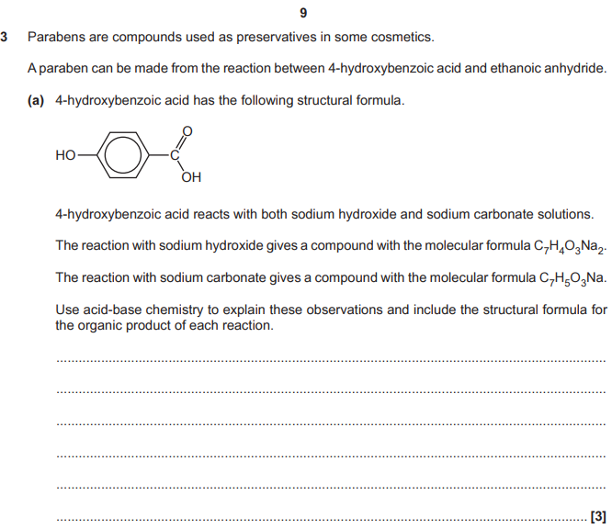  Use acid-base chemistry to explain these observations and include the structural formula for the organic product of each reaction.  - 4 hydroxybenzoic acid reacts with both sodium hydroxide and sodium carbonate solutions  - The reaction with sodium hydroxide gives a compound with the molecular formula C₇H₄O₃Na₂  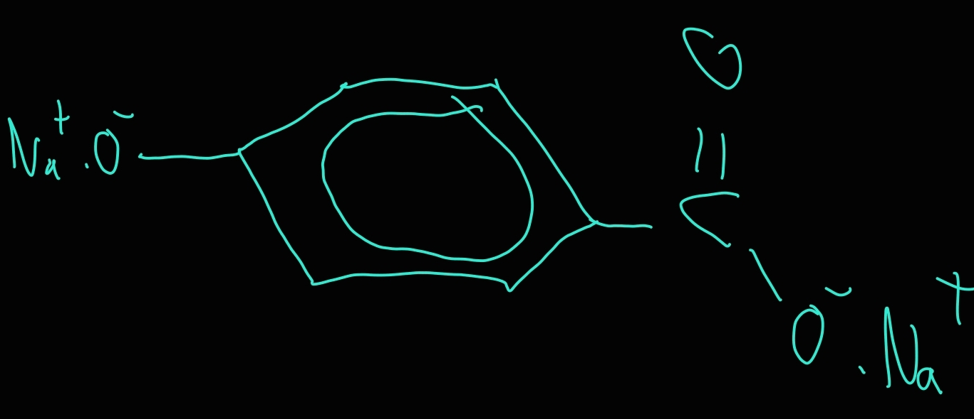  - The reaction with sodium carbonate gives a compound with the molecular formula C₇H₅O₃Na  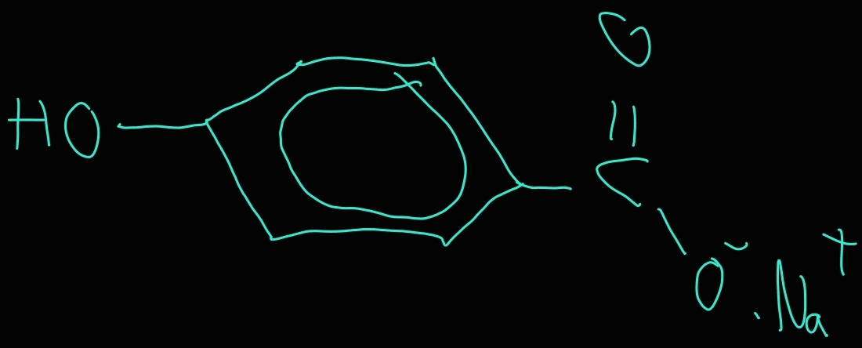 | - NaOH reacts with both the phenol and carboxyl (functional) groups to give NaOC₆H₄COONa  - Na₂CO₃ only reacts with the carboxyl (functional) group to give HOC₆H₄COONa  - The carboxyl (functional) group is more acidic than the phenol (functional) group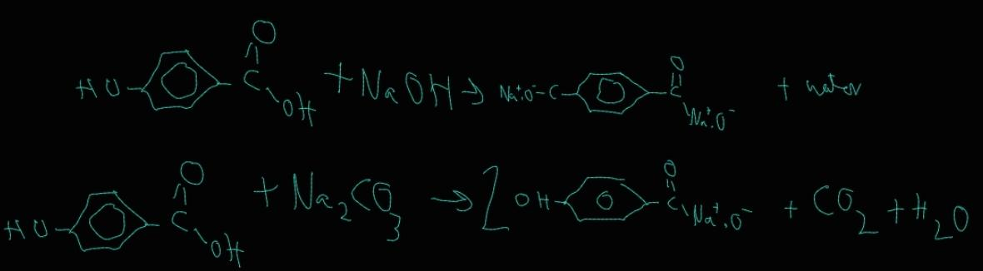
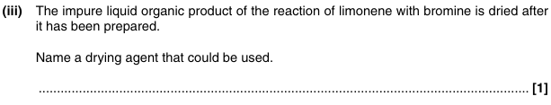  Name a drying agent that could be used? | - Sodium sulfate (Anhydrous)  - Conc H₂SO₄  - Silica gel  - Sodium carbonate (Anhydrous)  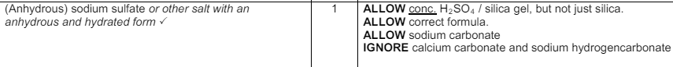
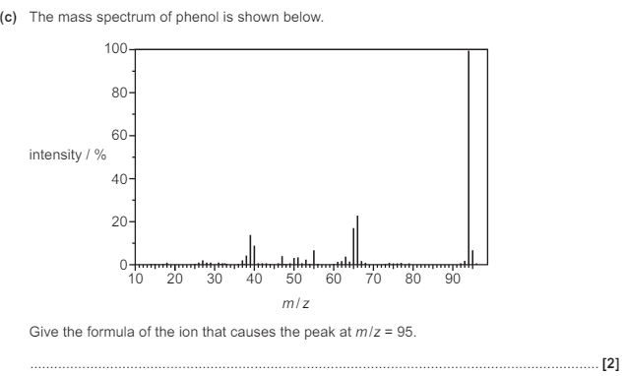  Give the formula of the ion that causes the peak at m/z = 95? (2) | 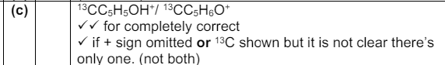  - [¹³CC5H5OH]⁺ / [¹³CC5H6O]⁺
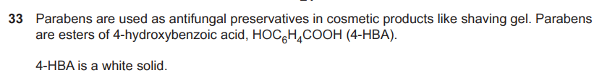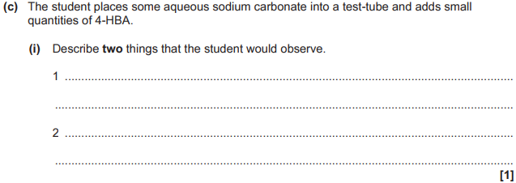  Describe 2 things that the student would observe? 4-HBA is solid. | 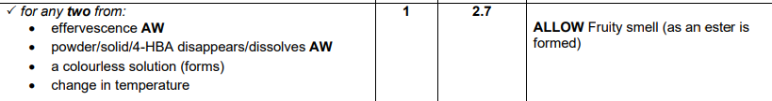  - Fizzing  - Solid dissolves  - A colourless solution  - Change in temperature  Allow fruity smell (as an ester is formed)
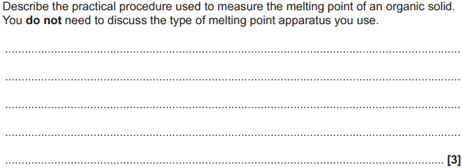  Describe the practical procedure used to measure the melting point of an organic solid? | - Seal/melt end of melting point/capillary tube  - Tap/tip/pack a small amount of solid to bottom of tube  - Put tube in mp apparatus allow temperature to rise slowly until solid melts OR record when it first starts to melt and when it finishes
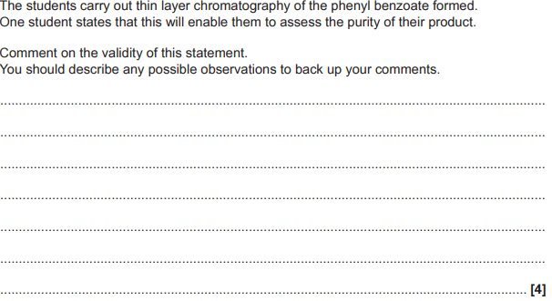  Comment on the validity of this statement? Phenyl benzoate is the ester that is formed in esterification from phenol and benzoic acid | 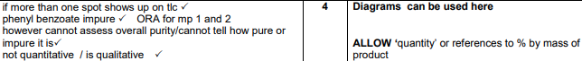  - If more than 1 spot shows up on TLC  - Phenyl benzoate impure  - However cannot assess overall purity / cannot tell how pure or impure it is  - It's not quantitative / it's qualitative

WM.a-b - Organic functional groups | WM1 | WM2 |
Functional group and suffix of aldehydes and name this compound (Think primary carboxyl group)  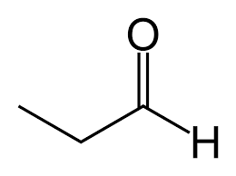  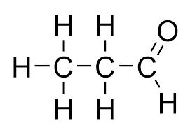 | - Functional group: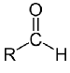  - Suffix: -al  - Propanal
Functional group and suffix of ketones and name this compound (Think secondary carboxyl group)  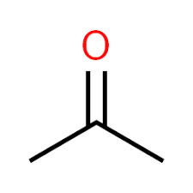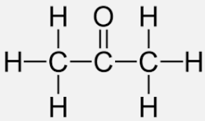 | - Functional group:  - 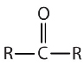  - General formula: C_{n}H_{2n}O  - Suffix: -one  - Propanone  - Ketone not bonded to one carbon
Functional group and suffix of carboxylic acids and name this compound  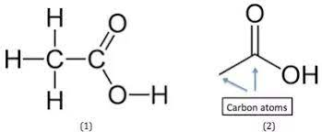 | - Functional group:  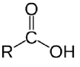  - General formula: C_{n}H_{2n+1}COOH  - Suffix: -oic acid  - Ethanoic acid  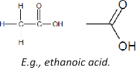
Functional group and suffix of esters and name this group and also How are esters named  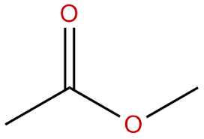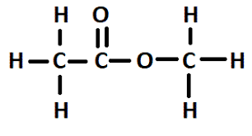 | - Functional group:  - General formula: C_{n}H_{2n}O₂  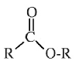  - Suffix -yl -oate  - Methyl ethanoate  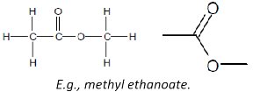  The alcohol ends in -yl and is the prefix. The carboxylic acid ends in -anoate and is the suffix  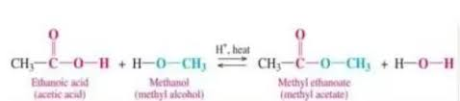
Functional group and suffix of acid anhydrides and name this compound  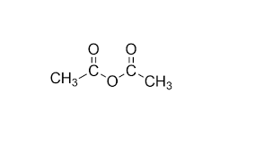 | - Functional group:  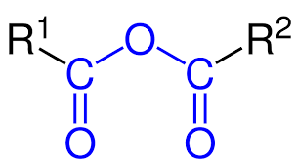  - Suffix: -oic anhydride  - Ethanoic anhydride  The branches from R₁ and R₂ are always symmetrical for this course
Functional group and suffix of ethers and name this compound :)  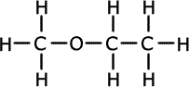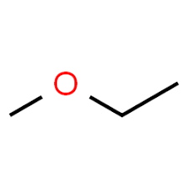 | - Functional group:  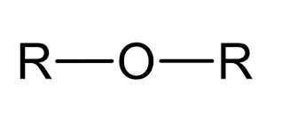  - Suffix: -oxy-  - Methoxyethane
What are the 3 degrees of alcohol? | - Primary (1st degree): -OH bonded to one other carbon atom  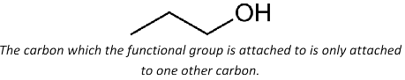  - Secondary (2nd degree): -OH bonded to a carbon bonded to two other carbon atoms  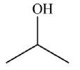  - Tertiary (3rd degree): -OH bonded to a carbon bonded to three other carbon atoms  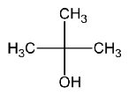

WM.c-g - Organic reactions | WM1 | WM2 | WM5 |
Why are shorter chain alcohols more soluble in water? | The functional group which forms hydrogen bonds with water molecules making it soluble forms a greater proportion of the molecule
What are the oxidising agents (reagents) for the oxidation of primary and secondary alcohols and where are they from? | - An excess of (Cr₂O₇²⁻/H⁺) from the solution of acidified potassium dichromate (VI) (ADP)  - Or potassium dichromate (VI) and sulfuric acid  Something such as hydrochloric acid cannot be used as the dichromate ions would rather oxidise this
What is the equation for the partial oxidation (with distillation) of primary alcohols? | A primary alcohol reacts with [O] (an oxidising agent) to form an aldehyde and water  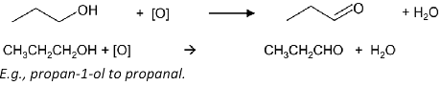
What are the reaction conditions for the partial oxidation of primary alcohols and why? | Distilling the aldehyde as it forms otherwise it will continue onto form a carboxylic acid
What is the equation for the full oxidation of a primary alcohol? | Primary alcohol + 2[O] -> carboxylic acid + water  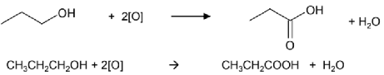  You can distil afterwards to remove any unreacted alcohol molecules
What is the equation for oxidation of secondary alcohols? | Secondary alcohol + [O] -> ketone + water  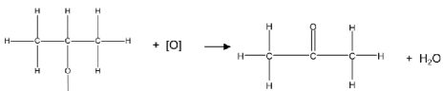
What are the reaction conditions for the full oxidation of primary alcohols and oxidation of secondary alcohols? AND Why? | Heating under reflux to prevent loss of reactants/products by evaporation
Why won’t tertiary alcohols oxidise? | As you need to remove a hydrogen atom from the carbon the -OH is bonded to (alongside the ¹H from the -OH group) Yet no hydrogen is bonded to said carbon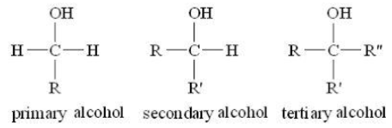
What is observed (colour-wise) under the oxidation of primary and secondary alcohols? | Orange to green colour change  [The orange dichromate (VI) ion, Cr₂O₇²⁻ (aq), is reduced to green chromate (III) ions, Cr³⁺ (aq), in the reaction. From textbook]
Describe and draw reflux setup? | 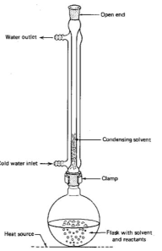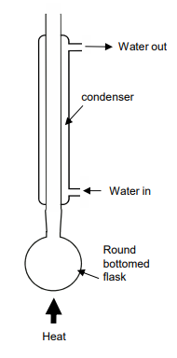  - Open end - prevents build up of gas that can cause explosion  - Anti-bumping granules - prevents vigorous and uneven boiling by forming smaller bubbles  - Don’t draw lines between flask and condenser  - Don’t have top of condenser sealed  - Condenser must have outer tube for water that is sealed at top and bottom  - Condenser must have two openings for water in and out that are open  For drawing labels  - Rounded bottomed flask/pear shaped  - Condenser  - Water in  - Water out
When is the reflux setup most often used? | When boiling organic reaction mixtures for long periods  Don’t say heating as some MS don’t allow
What are the products and conditions for the dehydration of alcohols and why? | - Forming an alkene and water from an alcohol  - Heat under reflux with concentrated sulphuric acid or  - Heat Alumina (Al₂O₃) at 300 degrees (using the setup as if we were cracking a long chain molecule)  - As we dont want any water to form alcohols again  In short, the same catalyst, however without water
What is the apparatus for the dehydration of alcohols using heated alumina at 300 degrees? | 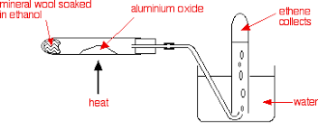  Same apparatus as cracking a long chain alkane
What type of reaction is the dehydration of alcohols? And why? | - Elimination  - The -OH group (and a H on an adjacent carbon) is eliminated forming an unsaturated molecule
When and why are isomers formed from the dehydration of alcohols? | - From secondary or tertiary alcohols  - As an H is removed from either one of the two/three adjacent carbons to the carbon the -OH is bonded to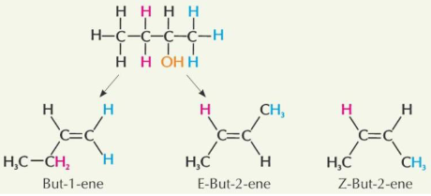
How are haloalkanes formed from alcohols? | Alcohols react with halide ions in the presence of a strong acid via nucleophilic substitution
Describe the esterification using an acid catalyst? | - Carboxylic acid + alcohol <-> ester + water  - Few drops of conc HCl or conc H₂SO₄ required for H⁺ ions (We use a strong acid catalyst as the reaction would be slow with a weak)  - Heat under reflux  - Reversible reaction and so there are reactants and products  - Ester is separated using distillation and is purified  Conc H2SO4 or other acid acts as a catalyst by removing water molecules so the POE would shift more to the right don’t believe we need to know how they remove water molecules but its a good thought
Describe the esterification using an acid anhydride with conditions? And what is achieved from using this compared to an acid catalyst | - Acid anhydride + alcohol -> ester + carboxylic acid  - Heating under reflux  - High yield achieved of ester compared to carboxylic acid as its not reversible
What is an acid anhydride? | Two different carboxylic acids joining together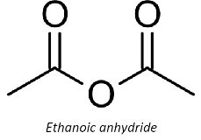
How can you purify an organic liquid? | - Pour the distillate (something formed from distillation ) of impure product into a separating funnel  - Wash with:  - NaHCO₃ solution to neutralise any acid impurities shake (and release pressure from CO₂ produced, add small volumes at a time, keep adding until no fizzing)  - Saturated NaCl solution to separate layers  3. Allow layers to separate and discard aqueous layer ( the organic layer will be on top usually due to a lower density)  4. Run organic layer into clean dry conical flask  5. Add a drying agent and swirl mixture (e.g. anhydrous sodium sulfate or calcium chloride) to dry liquid. When its dry it should be clear  6. Decant off liquid into flask  7. Redistill to collect pure product  Remember this as PWARADR  Please Write Addition Reactions And Draw Reactants  Decant means carefully pour the organic liquid in a separate beaker leaving the drying agent in the conical flask
What are the stages in order for purifying an organic liquid product? | - Distillation  - Neutralisation  - Separation  - Drying  - Redistillation  Although some questions tend to not mention the 1st step
Describe the setup for distillation with an explanation for key points | 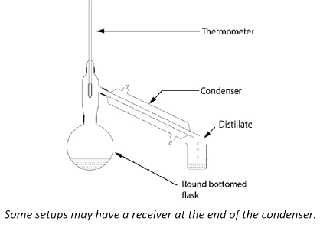  - Bulb of thermometer at T-junction - to displace the correct b.p  - Water entering via bottom of condenser - entire condenser will fill up before water exits  - Electric heater - prevents highly flammable organic compounds setting alight under a live flame  If water enters via the top of the condenser, it would trickle down and leave without filling the whole condenser
How is a separation funnel used?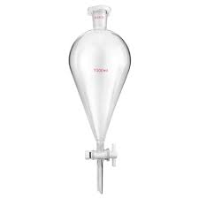 | - Shake the reaction mixture then allow to settle into a dense aqueous layer (containing the impurities bottom layer ) and a less dense organic layer (top layer)  - Open the tap to run off the aqueous layer (bottom layer)
What should you ensure with the drying agent for purifying organic liquids? | - Be insoluble in the organic liquid  - Not react with the organic liquid
How do alcohols react with bases? | They don’t because they are not acidic (pH = 7)
What is phenol? And name this please?  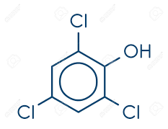 | - A benzene group with a -OH directly attached  - 2,4,6trichlorophenol
What type of acid is phenol and how will it react with NaOH (aq) and Na₂CO₃ (aq) ? | - A weak acid  - Reacts with NaOH (sodium salts)  - Does not react with strong bases such as Na₂CO₃ 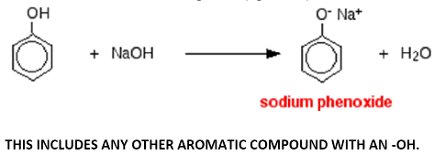
How can you distinguish between a phenol and a carboxylic acid? (Test to see whether a compound is a phenol or carboxylic acid) | Carboxylic acids will react with Na₂CO₃ producing effervescence (as CO₂ is produced) however phenols will not react
Does carboxylic acids react with NaOH (aq) and Na₂CO₃ (aq) | - They react with NaOH  - They react with Na₂CO₃
Do alcohols react with NaOH (aq) and Na₂CO₃ (aq) ? | Does not react with both as its pH = 7
What is the test for phenols? | Add Iron(III) chloride and turns solution from yellow to purple
What is the equation for esterification using phenols? | - Phenol + acid anhydride -> ester + carboxylic acid  - At RTP
Do phenols react with carboxylic acids to form esters like alcohols? | No as they are both acids
Rank in order for alcohols (ethanol), carboxylic acids, phenol and water which are least to most acidic? (These represent the acidic properties of the -OH group) | - Ethanol (weakest)  - Water (dissociates so some extent)  - Phenol (weak acid reacts with strong bases)  - Carboxylic acids (Weak acid reacts with strong base)
How is the solvent for recrystalisation chosen? Why? Otherwise what happens? | - Choose a solvent that dissolves when hot and doesn’t dissolve when cold  - If not soluble enough hot solvent won’t dissolve it all and so would not crystallise when cooling (1)  - If too soluble in cold solvent most will remain in solution when cooling giving low yield
How can you purify an organic solid by recrystallisation? Why is each step used? | - Choose a solvent that dissolves when hot and doesn’t dissolve when cold (Explained on a different FC)  - Dissolve the mixture in the minimum quantity of hot solvent (To ensure a saturated solution)  - Filter using filter paper (To remove any insoluble impurities)  - Cool filtrate until crystals form (So crystals form but soluble impurities remain in solution)  - Filter the crystals by vacuum filtration (To separate out crystals)  - Wash the crystals with a cold solvent then dry (To remove soluble impurities)  Remember this as CDFCFW  Can Deaf Fruity Crayons For Work  If solvent is mentioned e.g. ethanol make sure to say use cold or hot ethanol not just ‘solvent’  You can also scratch the inside surface with a glass rod to initiate crystallisation
By what 3 ways is yield lost under recrystalisation? | - Crystals lost when filtering/washing  - Some product stays in solution afterwards  - Side reactions occuring
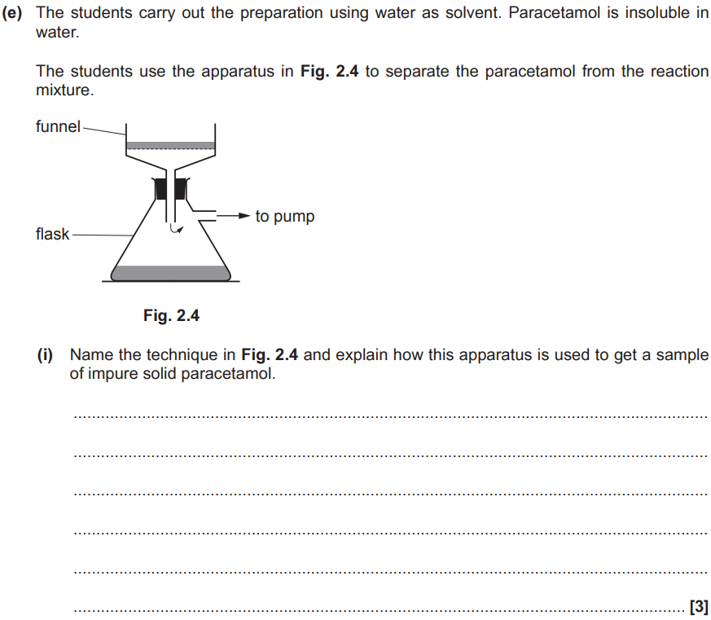  Describe the process of vacuum filtration (3)? | - Wash filter paper with water with organic solid (or solvent) [1]  - The suction would remove the water from filter paper (or solvent) [1]  - Organic solid is left on filter paper in the funnel [1]  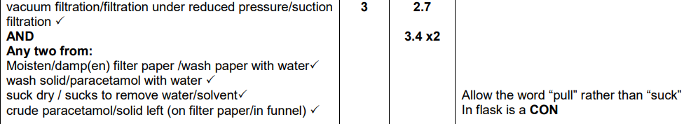
Draw the apparatus for vacuum filtration? | 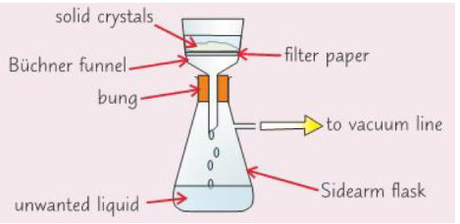  - Labelled: filter paper, buchner funnel, buchner flask, vacuum pump
Describe how a thin-layer chromatogram (TLC) is produced/Run? And mnemonic | - Draw a pencil line on TLC plate (1cm above the pencil line sometimes)*  - Line must be above solvent level * (so depth of solvent must be lower than the line)  - Spot mixture and pure samples onto pencil line *  - Place plate in a beaker of solvent *  - Cover the beaker with a lid *  - Remove plate when solvent front is near to top of plate  - Mark how far solvent has reached (in pencil)  - Allow plate to dry (by placing in a fume cupboard to evaporate solvent)  - Locate any spots with iodine crystals or using a UV lamp  Use mnemonic: Remember this as DLSPCRMAL  Do Line Solvent Properly Cause Ryan May Analyse Light  * Can be achieved by drawing a labelled diagram
How to calculate an R_{f} value from TLC and GC? | - Distance moved by spot/ distance moved by solvent  - By comparing to database values  - R_{f} always 1 or less  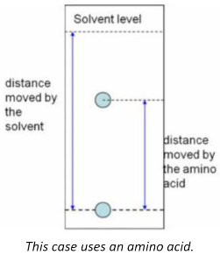  Each substance has its own unique retention factor
What problems are there with TLC? Why? | Some substances wont separate since they have similar retention factors/retention times because they are structurally similar  It is often used alongside mass spectroscopy
Describe how to melting point textbook  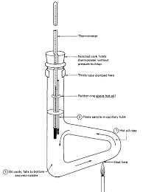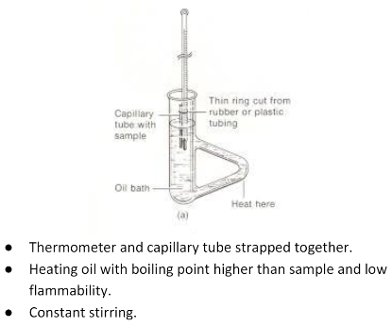 | - Seal the end of a glass melting point tube by heating it to melting in a bunsen flame  - Tap the open end of the tube into the solid so a small amount goes into the tube. Tab the tube so that the solid falls to the bottom of the sealed end  - Fix the tube in the melting point apparatus and heat the surroundings liquid gently, stirring to ensure even heating throughout. The temperature should rise very slowly  - Note the temperature at which the solid starts and finishes melting. The difference between the highest and lowest temperatures recorded is know as the melting range  - Compare the experimental value to the published value for the melting point. The wider the melting range, the more impure the substance. A pure compound will melt within 0.5 degrees of the true value
Give 2 ways melting point can be measured with a precaution? | - Using an electronic melting point machine  - Putting a capillary tube (with the product inside) into heating oil with a thermometer  - Heat slowly near melting point to record accurate temperature when it just melts
How can measuring the melting point of a product indicate purity? | - A very pure sample will have a sharp melting point (as quoted in data books)  - One with impurities may have a lower melting point or may melt over a range of several degrees
What are the 2 types of reactions under atom economy? | - Addition - the reactants form a single DESIRED product (100%)  - Substitution - the atom from a reactant are substituted by others leading to more than one product  Addition reactions are usually where a reactant is added to an unsaturated molecule to make saturated molecule
What is the principle of waste prevention? | - It is better to prevent the production of waste than to deal with it after it has been created  - As well as doing a reaction with less reagents and the number of steps
What is the principle of less toxic reactions? | - Reactions should be designed to have the least amount of toxic substances produced or used  - Use renewable reactants/products  - Also choose processes that minimise the potential for releasing gases, fire and explosions
What is the principle of safer solvents? | Reactions should be designed to minimise the use of organic solvents and separating agents that are dangerous
How can energy use be made more efficient in reactions? | - Reactions should be conducted at a lower temperature and pressure whenever possible  - The use of electricity should be minimised and the source of the electricity should be assessed (whether renewable or not)
Why are catalysts environmentally friendly and reduce energy demand? | - Catalysts reduce the need for heating in a reaction which reduces the amount of energy used for the reaction as well as the waste produced and are also more efficient  - (as they provide an alternate route of lower activation energy)  - Catalysts lower temperatures for reactions -> less fossil fuels are used reducing CO₂ emissions

WM.h - Reaction mechanisms | WM1 |

Define elimination reaction? | A reaction where a small molecule is removed from a larger molecule leaving an unsaturated molecule  In the case of alcohols the small molecule is water

WM.i-j - Modern analytical techniques | WM3 | WM4 |
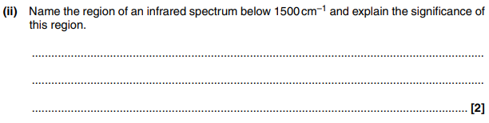  Name the region of an infrared spectrum below 1500 cm–1 and explain the significance of this region? (2) | 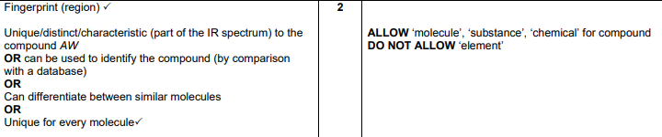  - Fingerprint region (1st)  - Can be used to identify the compound (1)  - Or unique to the compound (1)  - Or can differentiate between similar molecules (1)  - Or unique for every molecule
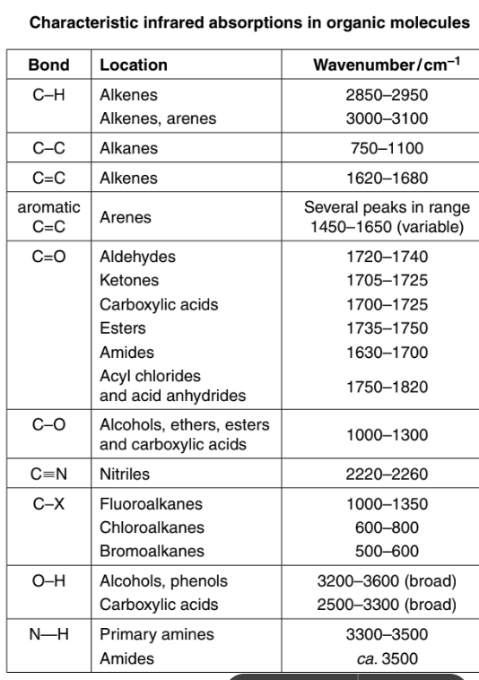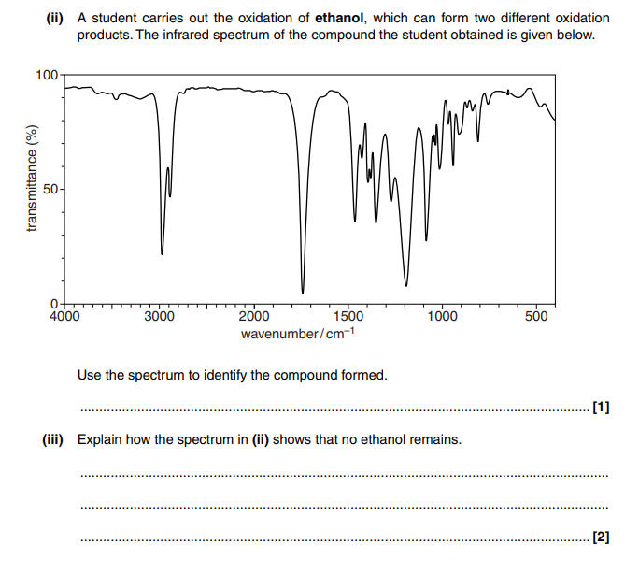  Explain how the spectrum in (ii) shows that no ethanol remains? (2) | 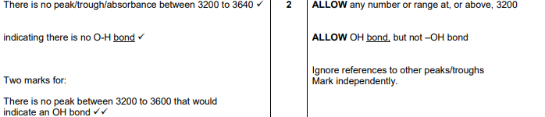  - There is no peak between 3200 and 3640cm⁻¹ (1)  - Indicating there is no O-H bond (1)
What are the lines on a mass spectrum? | - If analysing elements they’re isotopes  - If analysing compounds they’re fragment ions
What is the M+1 peak caused by and why is there unlikely to be a M+2 peak? (1) | The presence of a ¹³C isotope and the chance of 2 ¹³C is small (1)
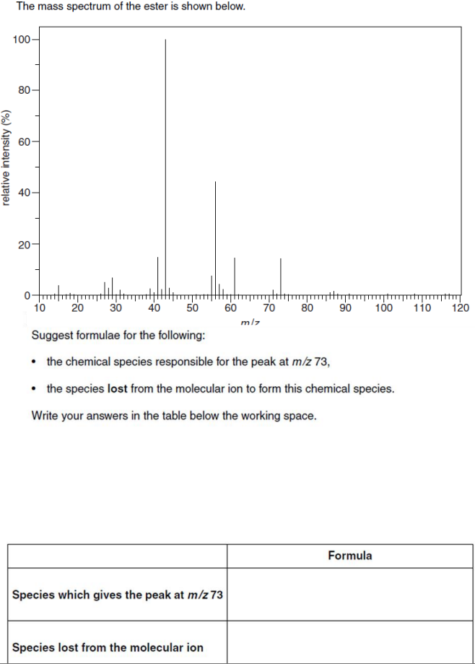  Mass spectrum for ester C₆H₁₂O₂/ CH3COOCH2CH2CH2CH3 (3) | 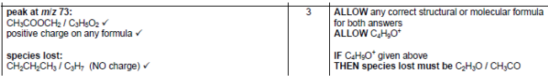  - Peak at m/z 73: [CH₃COOCH₂]+/[C₃H₅O₂]+ or [C4H9]+ (1)  - Positive charge on any formula (1)  - Species lost: CH2CH2CH3/C3H7 or C2H3O/CH3CO (NO charge) (1)
Steps for doing 4-6 markers for both Mass spectrometry and Infrared spectroscopy questions? | - Use Infrared to identify any functional groups in your unknown sample  - Use mass spectrometry to identify the structure and the mass of the molecule from fragment patterns (depending on the question they might give you the percentage composition by mass of the compound)

